KRITHIKA SHREE .K
24MIS0015

Q1)

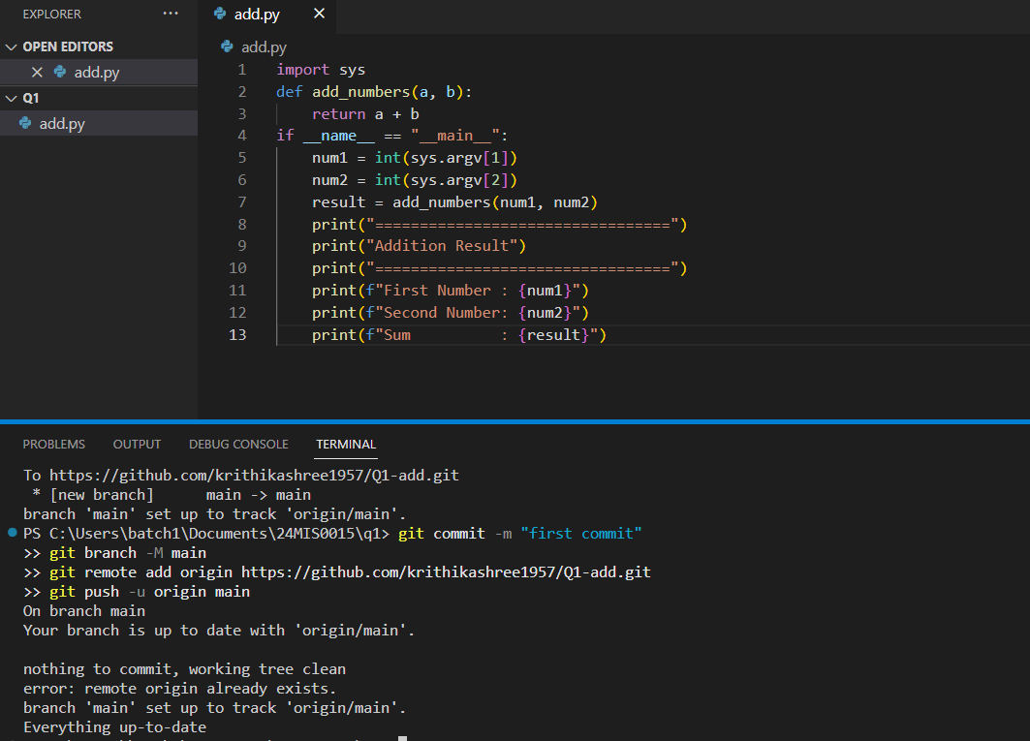

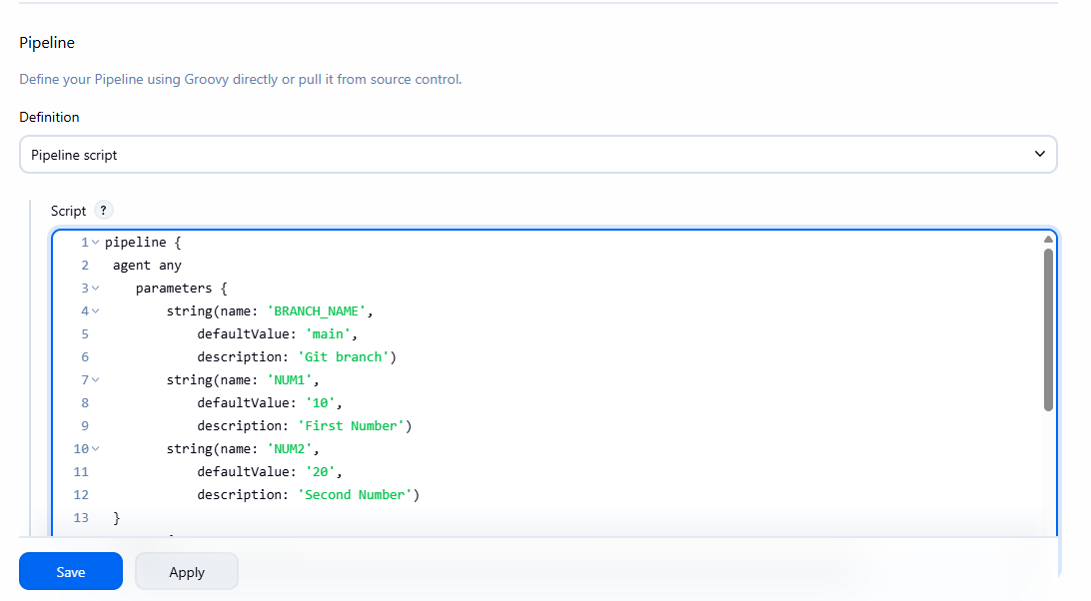
Pipleine code:
pipeline {
agent any
parameters {
string(name: 'BRANCH_NAME',
defaultValue: 'main',
description: 'Git branch')
string(name: 'NUM1',
defaultValue: '10',
description: 'First Number')
string(name: 'NUM2',
defaultValue: '20',
description: 'Second Number')
}
stages {
stage('Checkout') {
steps {
checkout scmGit(branches: [[name: '**']], extensions: [], userRemoteConfigs: [[url: 'https://github.com/krithikashree1957/Q1-add.git']])
}
}
stage('Addition Build') {
steps {
bat "python add.py ${params.NUM1} ${params.NUM2}"
}
}
}
}
Build:
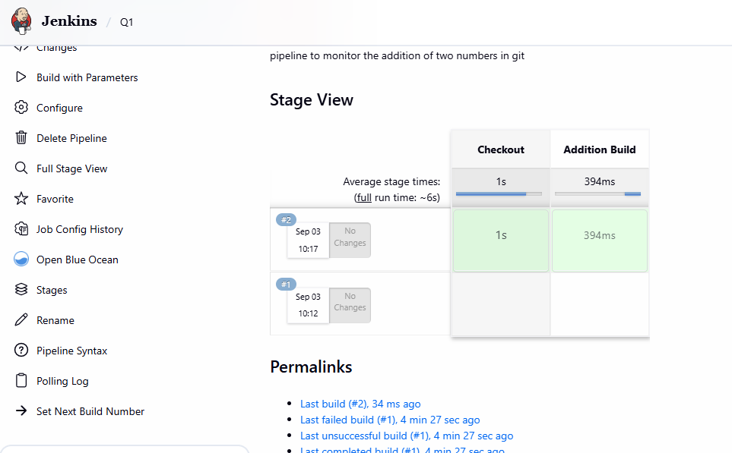
console output:

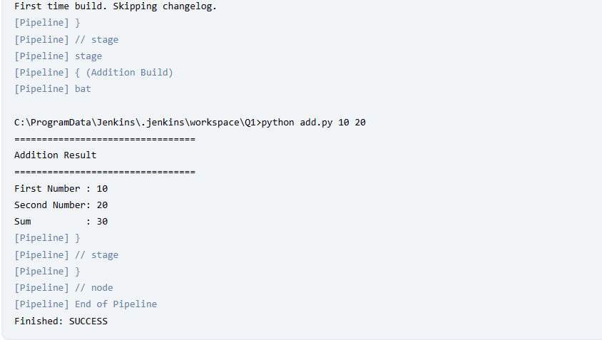

Q2)

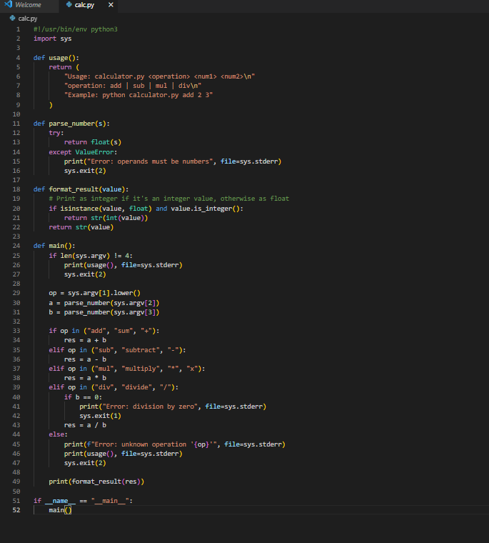

pipeline code:
pipeline {
agent any
parameters {
choice(name: 'OP', choices: "add\nsub\nmul\ndiv", description: 'Operation to perform')
string(name: 'A', defaultValue: '10', description: 'First operand')
string(name: 'B', defaultValue: '5', description: 'Second operand')
}
stages {
stage('Checkout') {
steps {
checkout scmGit(branches: [[name: '**']], extensions: [], userRemoteConfigs: [[url: 'https://github.com/krithikashree1957/Q2-calculator.git']])
}
}
stage('Run Calculator') {
steps {
bat "python calc.py \"${params.OP}\" \"${params.A}\" \"${params.B}\""
}
}
}
post {
always {
echo "Calculator pipeline finished"
}
}
}

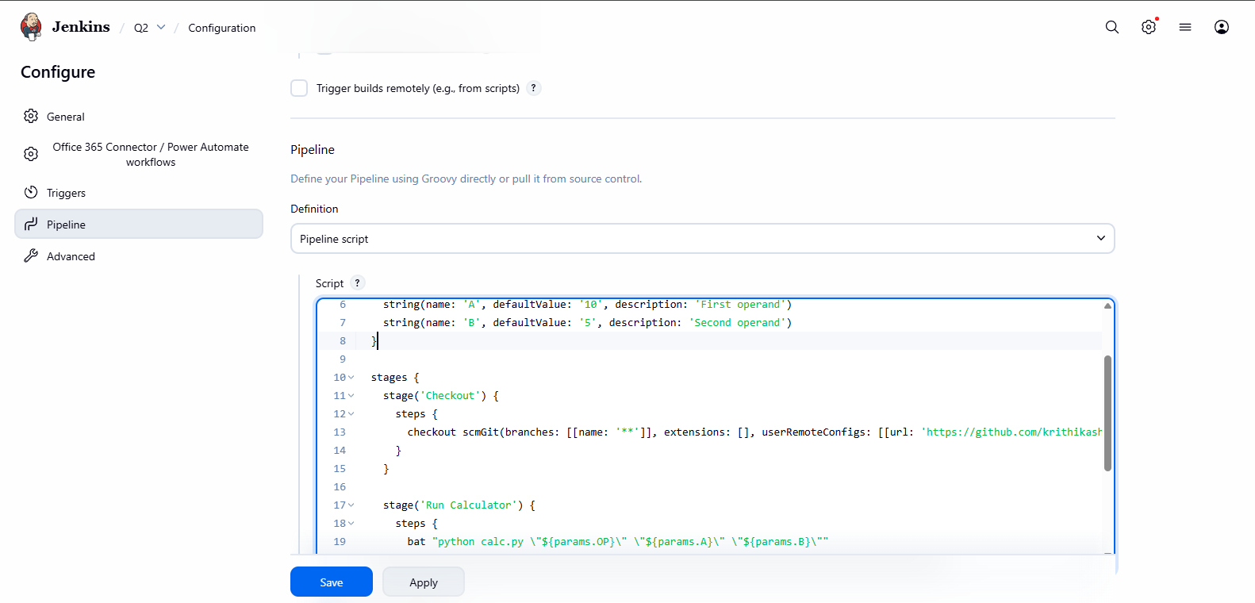

Build:

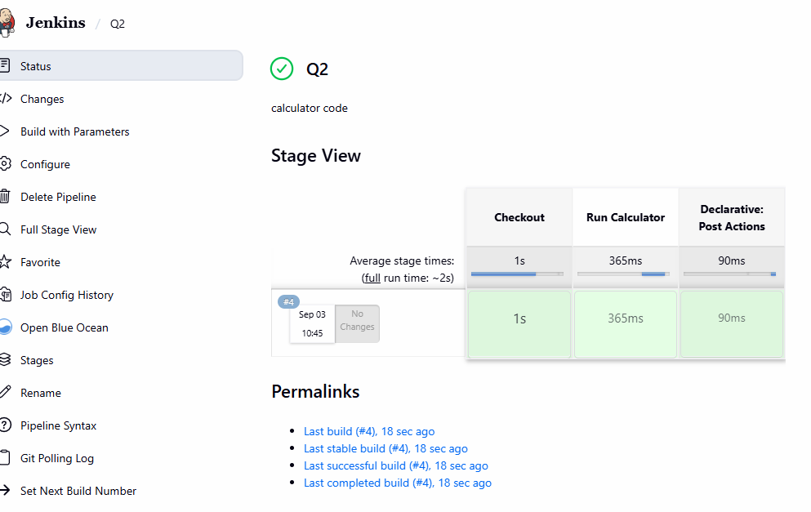

console output:

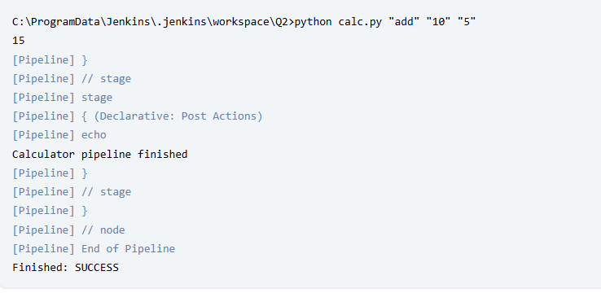

Q3)

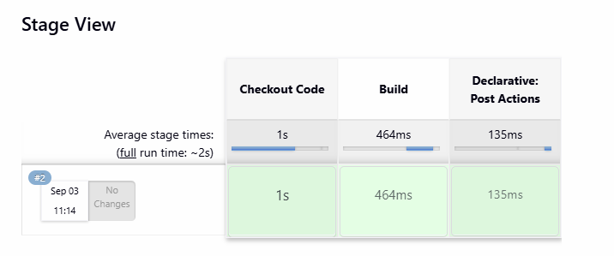
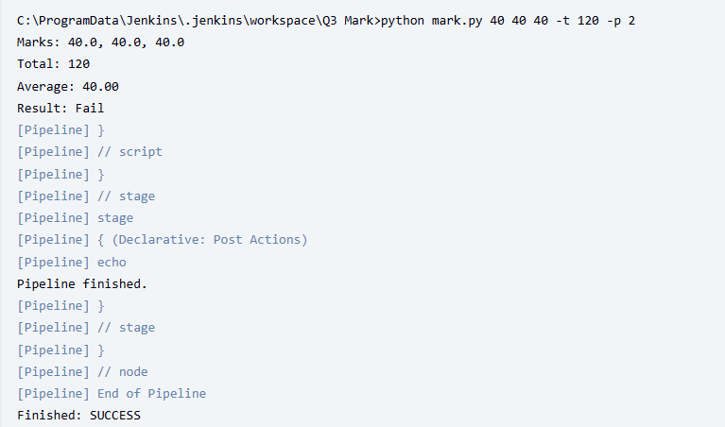
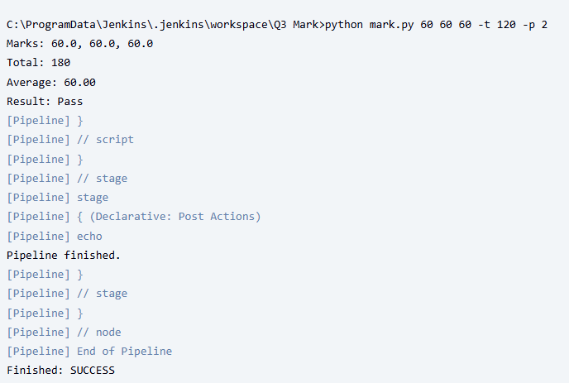

pipe line script:
pipeline {
agent any
parameters {
string(name: 'MARK1', defaultValue: '60', description: 'Marks for subject 1')
string(name: 'MARK2', defaultValue: '60', description: 'Marks for subject 2')
string(name: 'MARK3', defaultValue: '60', description: 'Marks for subject 3')
string(name: 'THRESHOLD', defaultValue: '120', description: 'Total pass threshold (numeric)')
string(name: 'PRECISION', defaultValue: '2', description: 'Decimal places for average')
}
stages {
stage('Checkout Code') {
steps {
checkout scmGit(branches: [[name: '**']], extensions: [], userRemoteConfigs: [[url: 'https://github.com/venikalaxmisaravanan/Marks-calculation.git']])
}
}
stage('Build') {
steps {
script {
// assemble argument string
def args = "${params.MARK1} ${params.MARK2} ${params.MARK3} -t ${params.THRESHOLD} -p ${params.PRECISION}"
if (isUnix()) {
sh "python3 mark.py ${args}"
} else {
bat "python mark.py ${args}"
}
}
}
}
}
post {
always {
echo 'Pipeline finished.'
}
}
}

